LABORATORIO ARTIGIANO RETI
di ARCHETTI CARLO
Reti da Pesca – Sport – Caccia
Recinzione Impianti Sportivi
Antinfortunistica – Acquacoltura
25058 SULZANO (BS) – Via Tassano, n. 8
Tel. e Fax 030/985290 – Tel. Ab. 030/985191
Cell. 328 0562071 c.f. RCHCRL64C01F532U – P.I. 03216410179
www.retiarchetti.it – info@retiarchetti.it
www.retiarchetti.com – info@retiarchetti.com
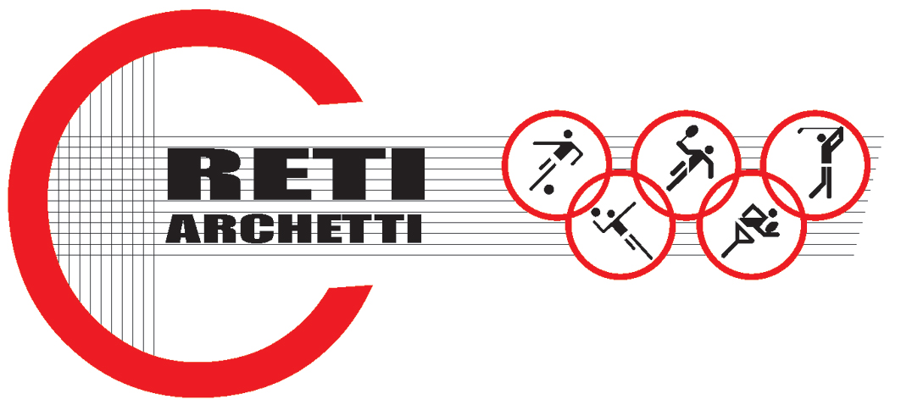

TECHNICAL DATA SHEET ART.CODE: AN 2
NET MADE OF HIGH RESISTANT NYLON, MESH mm 50 x 50, THICKNESS mm 5

STATIC TESTS: carried out on a nylon polyamide 6 (210/180) net, without knot, white colored (braid Ø5mm and mesh mm 50) according to Standard EN 1263 – 1
Hereafter the results obtained with tests on samples of a brand new net, dimensions 3 x 3m:

AVERAGE ULTIMATE STRENGTH: 2720,5 daN

Technical features

- MATERIAL: Nylon polyamide 6 title 210/180 without knot
- AVAILABLE COLORS: white
- YARN THICKNESS: 5 mm.
- NET: squared mesh
- MESH: mm 50 x 50
- WEIGHT: g. 390/ sq m

- EDGE STRIP: with a high resistant 10 mm nylon braid, sewed to the net. A piece of rope at the angles makes the installation easier.
- DIMENSIONS: on request.

